Sprint 2 Documentation
Group name: Cultural Connections
GitHub Repository link: https://github.com/Gencyigb/Cultural-connections
Project Board: https://github.com/users/Gencyigb/projects/1/views/1
Team Members:
- Lucie king – A00011608 – Project Manager
- Bahar Gencyigit – GEN23588035 – Developer
- Aderinola Animashaun – ANI21505735 – Developer
Contents
Section 1: User Stories 2
User Authentication and Profiles 2
Cultural content (Sprint 3 focus) 2
Section 2: Use Case Diagram 3
Section 3: Wireframes for our website layout 4
Section 4: Activity Diagrams 5
Login Page 5
View Posts Lists 6
Section 5: ERD diagram 7
Section 6: Kanban Board Screenshot 8
Section 7: Meeting Records 8

Section 1: User Stories

User Authentication and Profiles
ID | User Story | Priority
User 1 | As a visitor user, I want to be able to register for an account so I can take part in this community. | Medium
User 2 | As a user, I want to be able to log in securely so that I can access my profile. | Medium
User 3 | As a user, I want the ability to create and curate my profile with my cultural background so that others can learn about me. | Medium

Cultural content (Sprint 3 focus)
ID | User Story | Priority
User 1 | As a visitor, I want to be able to view a list of members so I can see who is a part of the platform. | Very High
User 2 | As a visitor, I want to click on a user and view their profile information so I can learn about their cultural background. | Very High
User 3 | As a visitor, I want to be able to browse different posts so I can discover new content. | Very High
User 4 | As a visitor, I want to click on a post and be able to view the full content of the post. | Very High
User 5 | As a visitor, I want to browse posts using category/tags, so I can filter contents by my interests. | Very High
User 6 | As a developer, I want the database to have sample data so it doesn’t feel empty. | High

Section 2: Use Case Diagram
Below is a use case diagram that shows what we expect different types of users to be able to do within the website (Made in Visio).
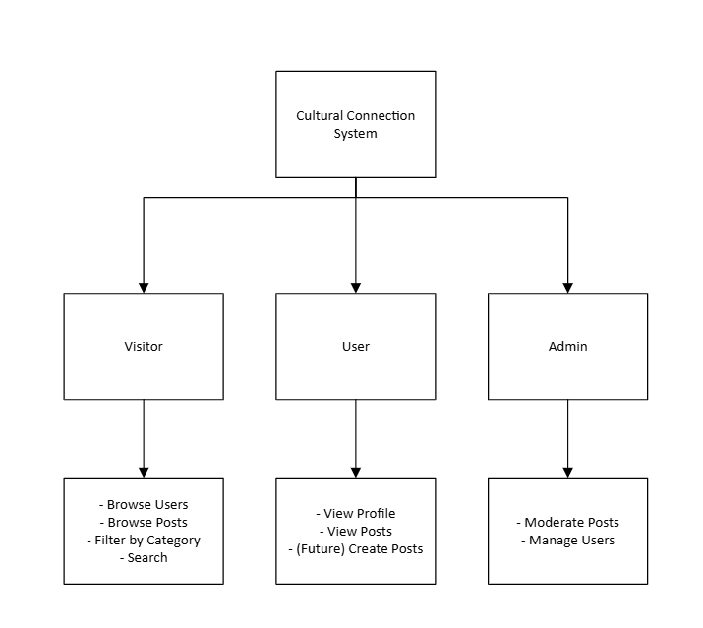

Section 3: Wireframes for our website layout
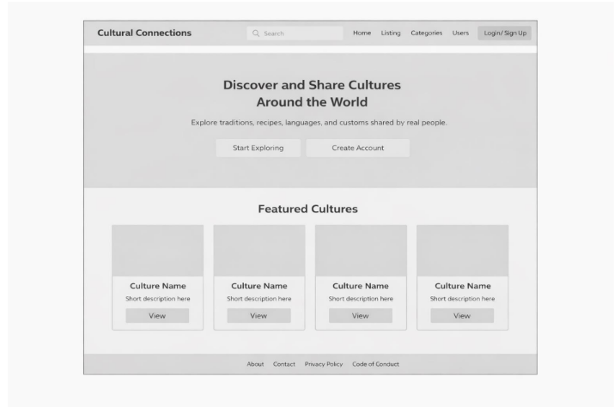
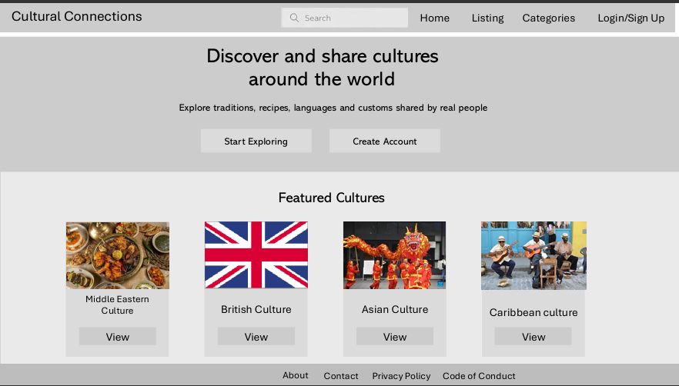

Section 4: Activity Diagrams

Login Page
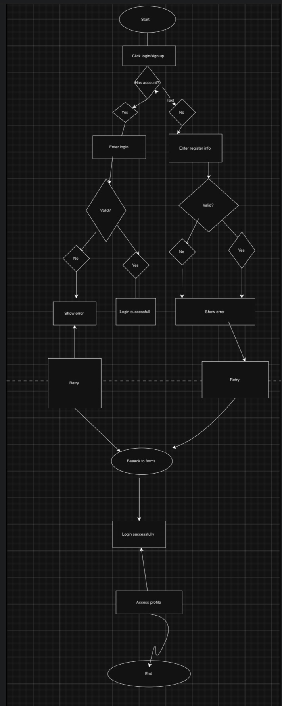

View Posts Lists
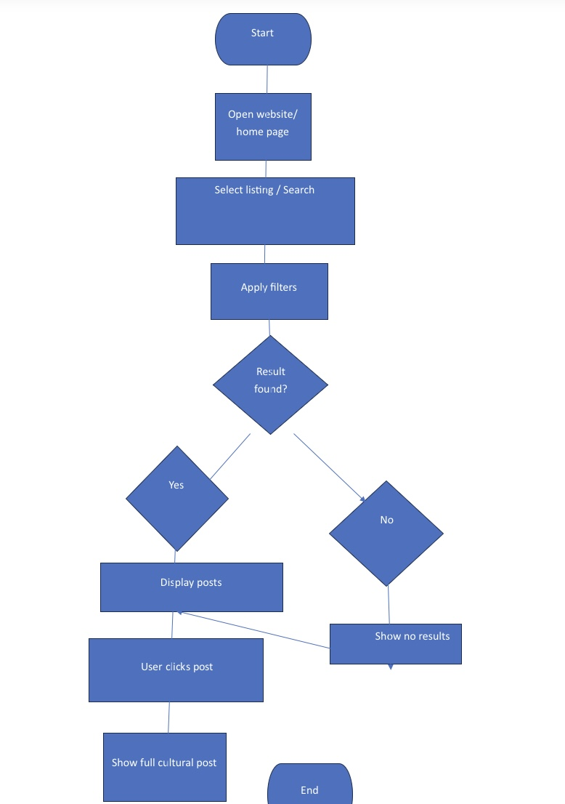

Section 5: ERD diagram
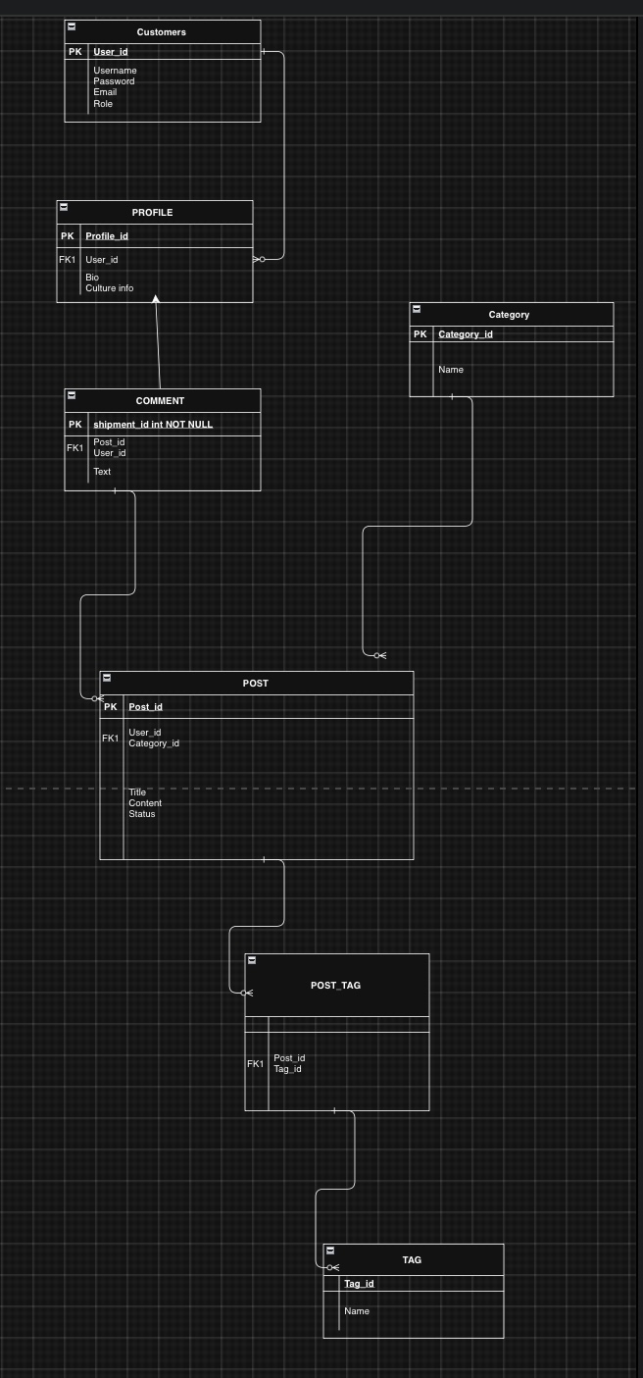

Section 6: Kanban Board Screenshot
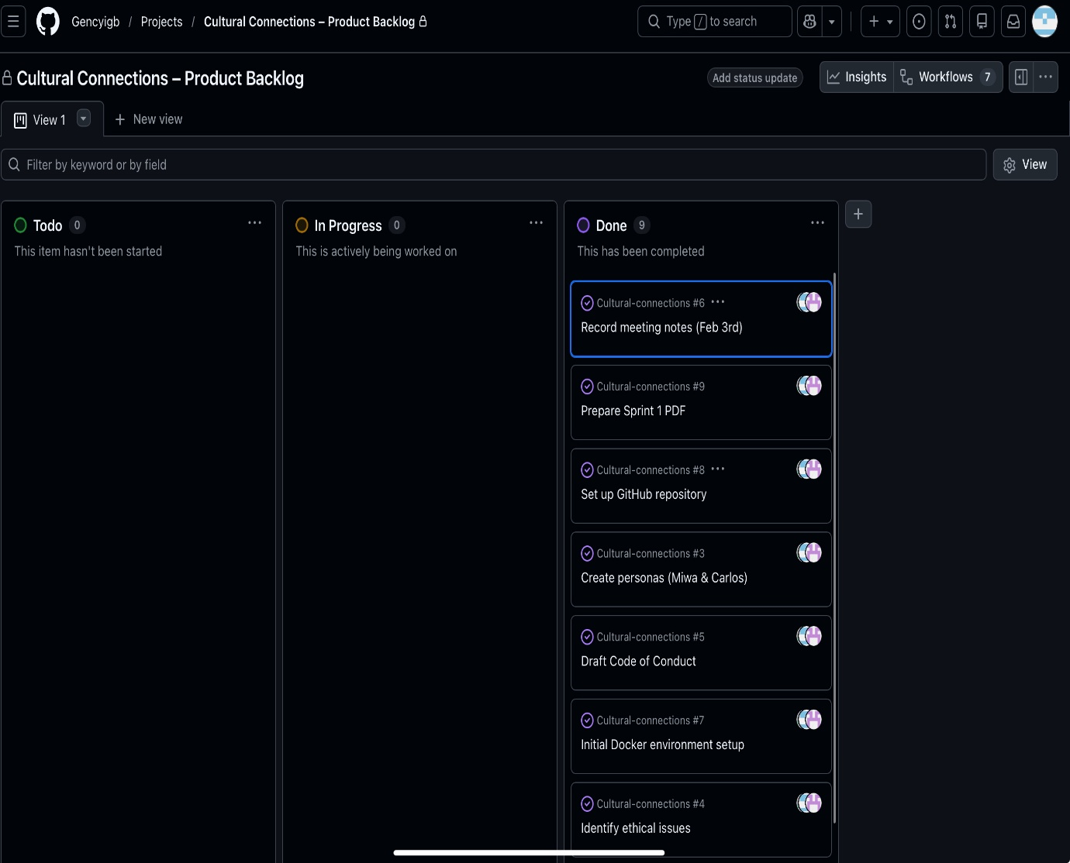

Section 7: Meeting Records
Meeting date: 17/02/2026
Time: 14:00
Meeting location: Via WhatsApp video call
Length: 15 minutes
Attendees: Lucie, Bahar, Aderinola
Agenda: Project ideation, Role Allocation, Tool Setup, User stories discussion, Wireframe Discussion, Database design.
We had a meeting via WhatsApp video call and discussed everything that concerned sprint 2. I (Lucie) allocated roles and work for each member of the team, and made sure they knew what they were doing. Everyone has clear instructions for their workload and are aware to keep everyone up to date with progress.

